Due to lacking equipment only one switch and PC will be used

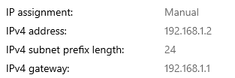  
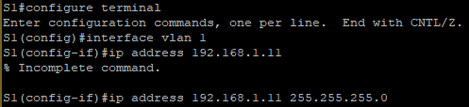

Ethernet adapter MAC address on PC-A

8C-EC-4B-78-F4-2E

Ethernet adapter MAC address on S1

a410.b6f6.e8c0

Are there any MAC addresses recorded in the MAC address table?

Yes there are multiple CPU MAC addresses as well as PC-A’s MAC address

What MAC addresses are recorded in the table? To which switch ports are they mapped?

The PC-A MAC address is present and is mapped to Gil/0/2 which is the second port available (column 1 row 2)

How could you tell which device the MAC address belongs to if it wasn’t recorded previously?

You could find the port and trace the cable, this method is not practical in majority of real world scenarios.

After clearing are any MAC addresses listed in the table?

There are MAC addresses but only the ones for the CPUs, the PC-A MAC address is gone.

After waiting have any new MAC addresses appeared in the table?

Yes the PC-A MAC address has reappeared in the table.

How many device IP-to-MAC address pairs have been learned by ARP?

There are 6 IP-to-MAC address pairs, 5 of them are from before the new manually set IP address for the lab.

Ping all available devices, are they successful?

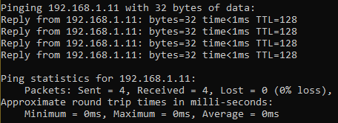  
  
Nothing new has appeared in any tables as the information was already present between them.